Home Work Problem Set 9
9-1 The magnetic field of Earth can be approximated as the magnetic field of a dipole. The horizontal and vertical components of this field at any distance r from Earth’s center are given by
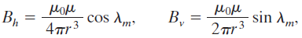
where λ_{m} is the magnetic latitude (this type of latitude is measured from the geomagnetic equator toward the north or south geomagnetic pole). Assume that Earth’s magnetic dipole moment has magnitude μ = 8.00 × 10²² A‧m². (a) Show that the magnitude of Earth’s field at latitudeλ_{m} is given by
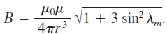
(b) Show that the inclination φ_{i} of the magnetic field is related to the magnetic latitudeλ_{m} by . (HRW 32-55)

9-2 A charge q is distributed uniformly around a thin ring of radius r. The ring is rotating about an axis through its center and perpendicular to its plane, at an angular speed ω. (a) Show that the magnetic moment due to the rotating charge has magnitude (b) What is the direction of this magnetic moment if the charge is positive? (HRW 32-60)

9-3 Consider a solid containing N atoms per unit volume, each atom having a magnetic dipole momentμ. Suppose the direction ofμcan be only parallel or antiparallel to an externally applied magnetic field B (this will be the case ifμis due to the spin of a single electron). According to statistical mechanics, the probability of an atom being in a state with energy U is proportional to e^{-U/kT}, where T is the temperature and k is Boltzmann’s constant. Thus, because energy U is -μ‧B, the fraction of atoms whose dipole moment is parallel to B is proportional to e^{μB/kT} and the fraction of atoms whose dipole moment is antiparallel to is proportional to e^{-μB/kT}. (a) Show that the magnitude of the magnetization of this solid is M = Nμtanh(μB/kT). Here tanh is the hyperbolic tangent function: tanh(x) = (e^{x} – e^{-x})/( e^{x} + e^{-x}). (b) Show that the result given in (a) reduces to M = Nμ²B/kT forμB<<kT. (c) Show that the result of (a) reduces to M = Nμ forμB>>kT. (d) Show that both (b) and (c) agree qualitatively with Fig. 32-14. (HRW32-45)

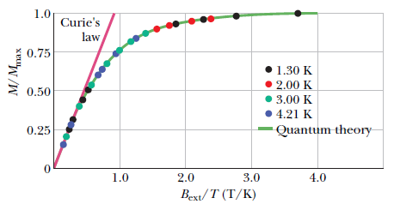
Fig. 32-14

